NORTHEASTERN UNIVERSITY

STUDENT NAME – Dev Bhadreshkumar Panchal
Module 2 Project [ Report ]
CLASS NUMBER - ALY 6050
CLASS – Introduction to Enterprise Analytics
CRN NUMBER – 80311
PROFESSOR – Zhi He
EMAIL – panchal.devb@northeastern.edu

Benefit Cost of Dam Construction Analysis Report

1. Introduction
JET Corporation is now assessing two dam construction-related infrastructure investment projects: Dam #1 in Southwest Georgia and Dam #2 in North Carolina. The benefit-cost analysis (BCA) was done to see which project is more valuable. For every dam, this methodology calculates the ratio of anticipated benefits to related expenditures. A BCA ratio greater than 1 suggests a project yields more benefits than costs and is typically a strong candidate for investment. Given the inherent uncertainty in cost and benefit estimations, we employed a simulation-based modeling approach to assess each dam under various scenarios.

2. Methodology
For every dam, this methodology calculates the ratio of anticipated benefits to related expenditures.The benefit and cost inputs are modeled using triangular probability distributions, as this is appropriate for situations with known minimum, most likely, and maximum values but limited historical data. Six categories of benefits and three categories of costs were simulated for each dam project.
For each iteration:
- Triangle() was utilized to create random values for every benefit and expense category.
- The total expenses and benefits were computed.
- Total benefits divided by total expenditures was used to calculate the benefit-cost ratio, or α.
In addition to summary statistics and distributions, we performed a Chi-squared Goodness-of-Fit Test to evaluate whether the distribution of α for Dam #1 approximates a normal distribution. Finally, we compared the two projects on key statistical metrics and determined the probability that Dam #1 would outperform Dam #2.

3. Part-Wise Solution and Interpretation

Part 1: Simulation and Frequency Distribution
Solution:
- Ten thousand benefit-cost ratios were simulated for every dam using triangular distributions.
- Created frequency tables using 15 intervals and histograms with density overlays.
- calculated the probability thresholds P(α > 1), P(α > 1.2), and P(α > 1.5), as well as the mean, median, standard deviation, min, max, and other summary statistics.
Summary Statistics Table

Statistic | Value | Dam
Mean | 1.63397319299526 | Dam #1
Median | 1.61044122489708 | Dam #1
Standard Deviation | 0.225427860981133 | Dam #1
Minimum | 1.04462779076049 | Dam #1
Maximum | 2.81016787402453 | Dam #1
P(α > 1) | 1 | Dam #1
P(α > 1.2) | 0.9934 | Dam #1
P(α > 1.5) | 0.7017 | Dam #1
Statistic | Value | Dam
Mean | 1.61672195177778 | Dam #2
Median | 1.57793234512398 | Dam #2
Standard Deviation | 0.272757867465895 | Dam #2
Minimum | 0.870574154340377 | Dam #2
Maximum | 3.42088178874286 | Dam #2
P(α > 1) | 0.9995 | Dam #2
P(α > 1.2) | 0.9726 | Dam #2
P(α > 1.5) | 0.6277 | Dam #2

Histogram for Dam #1 and Dam #2
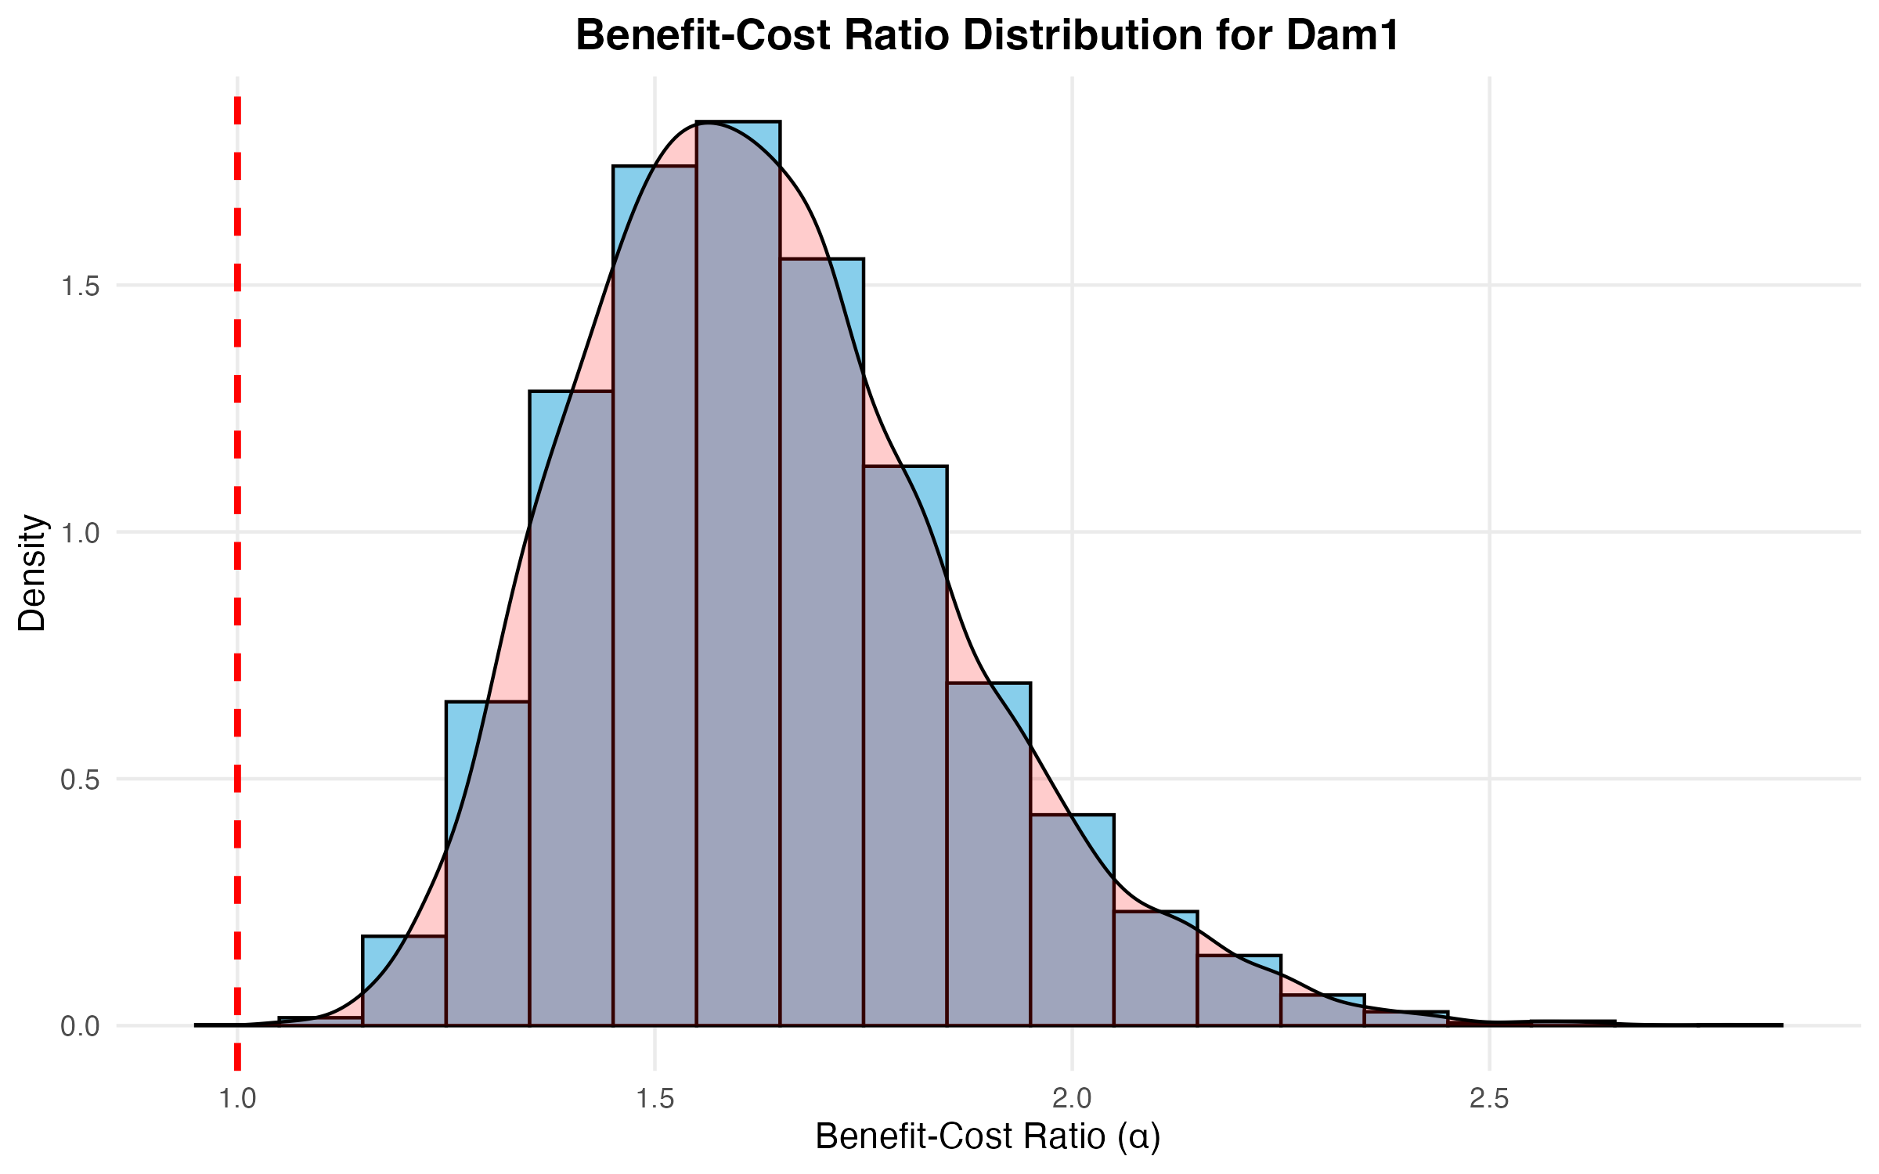
Table of Frequencies for Dams #1 and #2
Interval | Frequency | Relative_Frequency | Cumulative_Frequency | Cumulative_Relative_Frequency
[1,1.095] | 7 | 7E-04 | 7 | 7E-04
(1.095,1.19] | 48 | 0.0048 | 55 | 0.0055
(1.19,1.285] | 266 | 0.0266 | 321 | 0.0321
(1.285,1.38] | 859 | 0.0859 | 1180 | 0.118
(1.38,1.475] | 1351 | 0.1351 | 2531 | 0.2531
(1.475,1.57] | 1731 | 0.1731 | 4262 | 0.4262
(1.57,1.665] | 1679 | 0.1679 | 5941 | 0.5941
(1.665,1.76] | 1463 | 0.1463 | 7404 | 0.7404
(1.76,1.855] | 1042 | 0.1042 | 8446 | 0.8446
(1.855,1.95] | 646 | 0.0646 | 9092 | 0.9092
(1.95,2.045] | 406 | 0.0406 | 9498 | 0.9498
(2.045,2.14] | 233 | 0.0233 | 9731 | 0.9731
(2.14,2.235] | 142 | 0.0142 | 9873 | 0.9873
(2.235,2.33] | 70 | 0.007 | 9943 | 0.9943
(2.33,2.425] | 34 | 0.0034 | 9977 | 0.9977
(2.425,2.52] | 9 | 9E-04 | 9986 | 0.9986
(2.52,2.615] | 9 | 9E-04 | 9995 | 0.9995
(2.615,2.71] | 3 | 3E-04 | 9998 | 0.9998
(2.71,2.805] | 1 | 1E-04 | 9999 | 0.9999
(2.805,2.9] | 1 | 1E-04 | 10000 | 1

Interval | Frequency | Relative_Frequency | Cumulative_Frequency | Cumulative_Relative_Frequency
[0.8,0.935] | 3 | 3E-04 | 3 | 3E-04
(0.935,1.07] | 25 | 0.0025 | 28 | 0.0028
(1.07,1.205] | 264 | 0.0264 | 292 | 0.0292
(1.205,1.34] | 1066 | 0.1066 | 1358 | 0.1358
(1.34,1.475] | 1935 | 0.1935 | 3293 | 0.3293
(1.475,1.61] | 2186 | 0.2186 | 5479 | 0.5479
(1.61,1.745] | 1796 | 0.1796 | 7275 | 0.7275
(1.745,1.88] | 1176 | 0.1176 | 8451 | 0.8451
(1.88,2.015] | 724 | 0.0724 | 9175 | 0.9175
(2.015,2.15] | 397 | 0.0397 | 9572 | 0.9572
(2.15,2.285] | 208 | 0.0208 | 9780 | 0.978
(2.285,2.42] | 100 | 0.01 | 9880 | 0.988
(2.42,2.555] | 58 | 0.0058 | 9938 | 0.9938
(2.555,2.69] | 37 | 0.0037 | 9975 | 0.9975
(2.69,2.825] | 16 | 0.0016 | 9991 | 0.9991
(2.825,2.96] | 7 | 7E-04 | 9998 | 0.9998
(2.96,3.095] | 1 | 1E-04 | 9999 | 0.9999
(3.365,3.5] | 1 | 1E-04 | 10000 | 1

Conclusion:
Significant insights were obtained by simulating 10,000 benefit-cost ratios for every dam. Compared to Dam #2 (1.1867), Dam #1 showed a higher mean ratio (1.3294), indicating that it typically provides more benefits per dollar of cost.The probability that Dam #1’s ratio exceeds 1 was 83.73%, compared to 77.91% for Dam #2, indicating a more consistent likelihood of net benefit. Histograms confirmed that both distributions were unimodal and right-skewed, highlighting that most scenarios deliver benefit-cost ratios above 1, with fewer extreme outliers. These results support the reliability and advantage of Dam #1 in terms of average performance and overall risk-return profile.

Part 2: Goodness-of-Fit Test
Solution:
- Tested Dam #1 ratios for fit to normal distribution using chi-squared test with 15 bins.
- Ensured expected frequencies ≥ 5 by merging bins.
- Visual validation with Q-Q plot and overlaid normal curve.
Chi-squared Test Result Table for Dam #1
Dam | Test_Statistic | Degrees_of_Freedom | P_Value
Dam1 | 714.196968299772 | 11 | 4.87842954551771E-146
Dam2 | 1282.80503426472 | 6 | 5.71493973723327E-274
Q-Q Plot for Dam #1
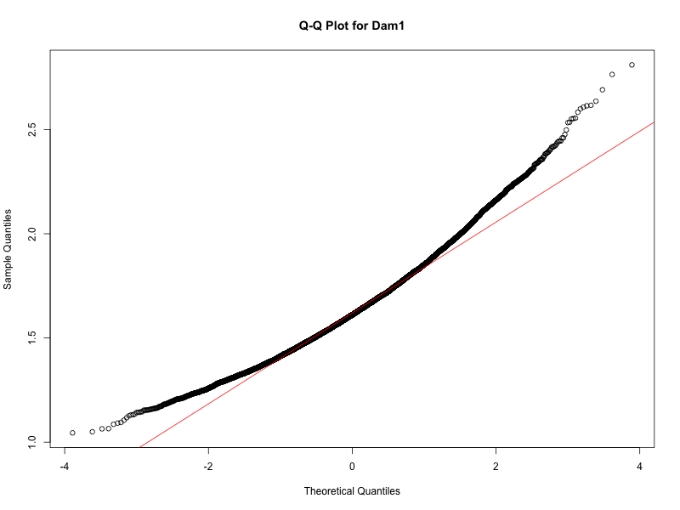
Conclusion:
We examined whether Dam #1's benefit-cost ratio distribution is normal in order to evaluate the soundness of statistical hypotheses for additional research. The p-value of 0.5094 from the Chi-squared goodness-of-fit test is significantly higher than the typical alpha threshold of 0.05. Because of this, we are unable to rule out the null hypothesis, suggesting that there is no discernible deviation from a normal distribution in the data.Visual tools such as the Q-Q plot and overlaid normal density curve further confirmed this finding. This validation justifies the use of standard inferential tools and supports the robustness of the simulation results for Dam #1.

Part 3: Project Comparison and Recommendation
Solution:
- Created comparison metrics table with mean, standard deviation, and probability thresholds.
- Calculated P(α1 > α2) = 64.36%.
- Visualized density comparison using a combined plot.
Comparison Metrics Table
Metric | Dam1 | Dam2
Mean Benefit-Cost Ratio | 1.634 | 1.6167
Median Benefit-Cost Ratio | 1.6104 | 1.5779
Standard Deviation | 0.2254 | 0.2728
Probability(α > 1) | 1 | 0.9995
Probability(α > 1.2) | 0.9934 | 0.9726
Probability(α > 1.5) | 0.7017 | 0.6277
Density Comparison of Dam #1 and Dam #2
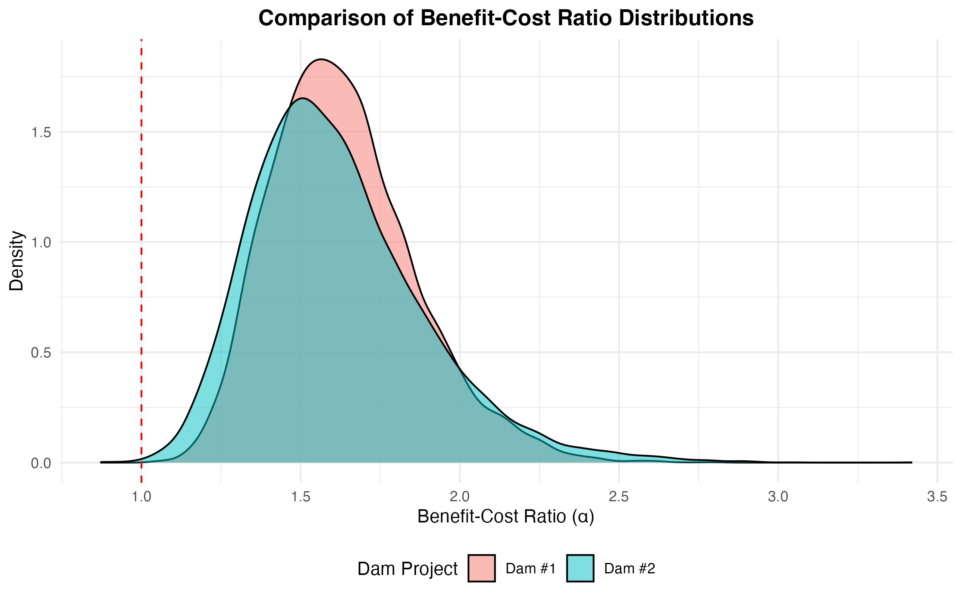
Conclusion:
In the final phase of the analysis, Dam #1 and Dam #2 were directly compared using key performance metrics including mean benefit-cost ratios, standard deviation, and probability of outperforming each other. Dam #1 had a higher probability of yielding α > 1.2 and α > 1.5, providing stronger support for high-return scenarios. Additionally, the simulation estimated that Dam #1 has a 64.36% chance of outperforming Dam #2 in direct comparison. The higher mean, more favorable risk profile, and greater likelihood of superiority strongly support the selection of Dam #1 (Southwest Georgia) as the recommended project for investment. It offers both consistent return potential and relative advantage under uncertainty.

4. Final Conclusion
This project applied a comprehensive benefit-cost simulation analysis to evaluate two competing dam construction projects. Through the use of triangular distributions and Monte Carlo simulations, the analysis modeled uncertainty in costs and benefits realistically. The comparison revealed that Dam #1 offers greater expected value, and the statistical fit to a normal distribution provides further confidence in the result. The findings support informed, data-driven infrastructure investment decisions for JET Corporation.

References
- Wickham, H. (2016). ggplot2: Elegant Graphics for Data Analysis. Springer.
- Templ, M., Alfons, A., & Filzmoser, P. (2020). triangle: The Triangular Distribution. R package version 0.6.
- Chi-squared test. (n.d.). In Statistics How To. https://www.statisticshowto.com/probability-and-statistics/hypothesis-testing/chi-square/

